UI Design document – foodify

HAMZAH MALIK – ACSF375

Contents

Purpose and scope of the document 3

Wireframes – Adobe XD 3

Intended audience of the document 3

Display properties, Android devices 4

Colour schemes and Colour Theory 4

Initial Wireframe Designs 5

# Purpose and scope of the document

As part of my final year university project, I have chosen to develop an augmented reality restaurant application; labelled Foodify – that aims to bring augmented reality functionality to restaurant menus.

I have created this document to showcase the user interface designs I have created as part of the planning and documentation stages of the development lifecycle. As I have chosen to take an incremental design approach to this project, ensuring project work is split into clusters is the most efficient way of handling the delivery of the project, and the design stages is one of the most important.

Designs are based on a combination of my own design ideas for the application UI and research into existing restaurant-based menu applications such as UberEats, Deliveroo, JustEat (e.t.c). The designs created for the UI are representative of the required functionality discovered earlier into the project from the requirements specification document.

# Wireframes – Adobe XD

The designs are modelled as wireframes to distinguish key functionality from within each app page such as buttons, images, text fields and AR scenes. These wireframes were created using Adobe XD from initial sketches created by hand – Adobe XD was chosen as the software for the wireframes due to how easy it is to use. Adobe XD also supports wireframe interactions, where users can place interactions between each page.

These interactions help decipher what buttons or pages lead to other pages within the Foodify application itself.

As requirements constantly change during the development lifecycle of a project, it’s important to note that these designs within the document are not to be considered the final versions, as requirements may change later in development. Whilst these may not be a completely accurate depiction of the final version of the application itself, they serve as an excellent guideline for the development stages of the project, where they can be used as reference for front-end UI designs.

# Intended audience of the document

This document is intended to be read by myself, the developer. As mentioned previously, this design document will prove to be essential as reference when developing the Foodify application itself.

# Display properties, Android devices

Foodify is intended to be run on Android devices running on a minimum of Android 7. This is because Foodify uses the ARCore /ARFoundation frameworks which were not around before Android 7’s existence, hence Android 7+ being a minimum requirement.

Whilst there does exist a range of Android devices with different aspect ratios in terms of screen display sizes, they typically use similar aspect ratios. Therefore, the designs of the Foodify application are based on a standard screen size found of most Android smartphones in the portrait orientation.

Whilst some of my wireframes do run in horizontal display formats, for the purpose of referencing and functionality, they have been created in portrait format. This includes only the AR plane scenes for the context of the application.

# Colour schemes and Colour Theory

# Initial Wireframe Designs

## Wireframe 1 – Page 1

This was the first of the three proposed wireframes designed for the Foodify application. This UI template was designed by me, attempting to contextualise how the application could look based on the given functionality.

The wireframe page one shows the landing page, and the welcome messages attached to the page for the user to view. It also shows a drop-down list for people to click on to view the help/Q&A page and the search page/button.

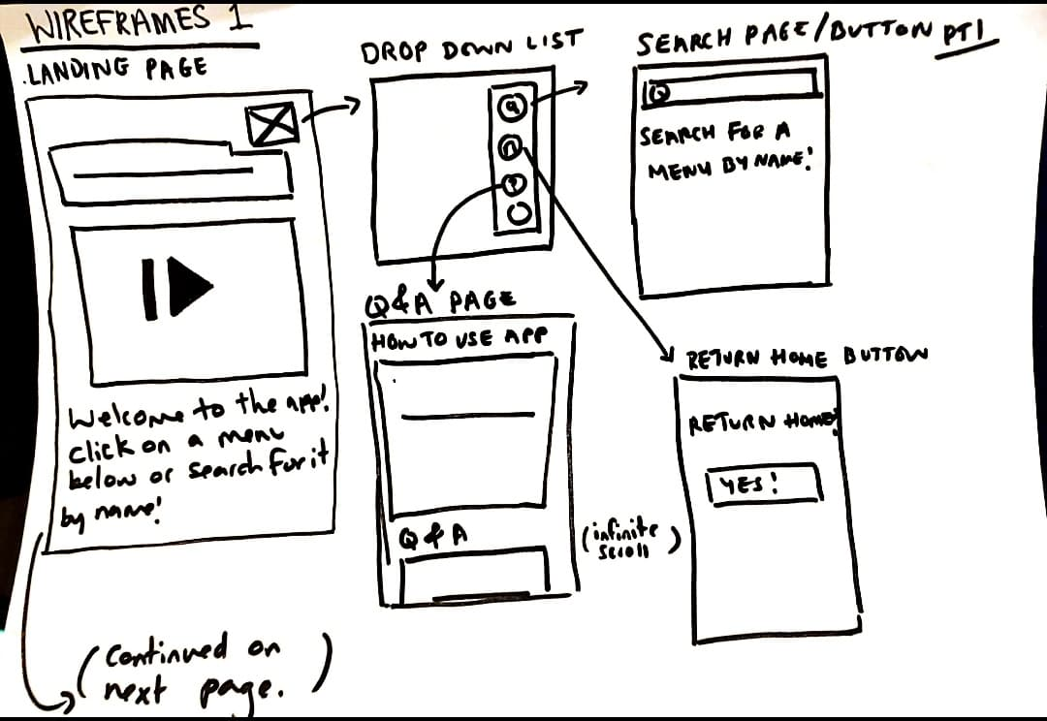

## Wireframe 1 – Page 2

This is the second page of the first set of wireframes, focused on showcasing the functionality of the augmented reality plane scene. It shows how the from the landing page (or from returned search results), users can select a menu that leads them to the augmented reality scene attached to each menu (with each menu being unique).

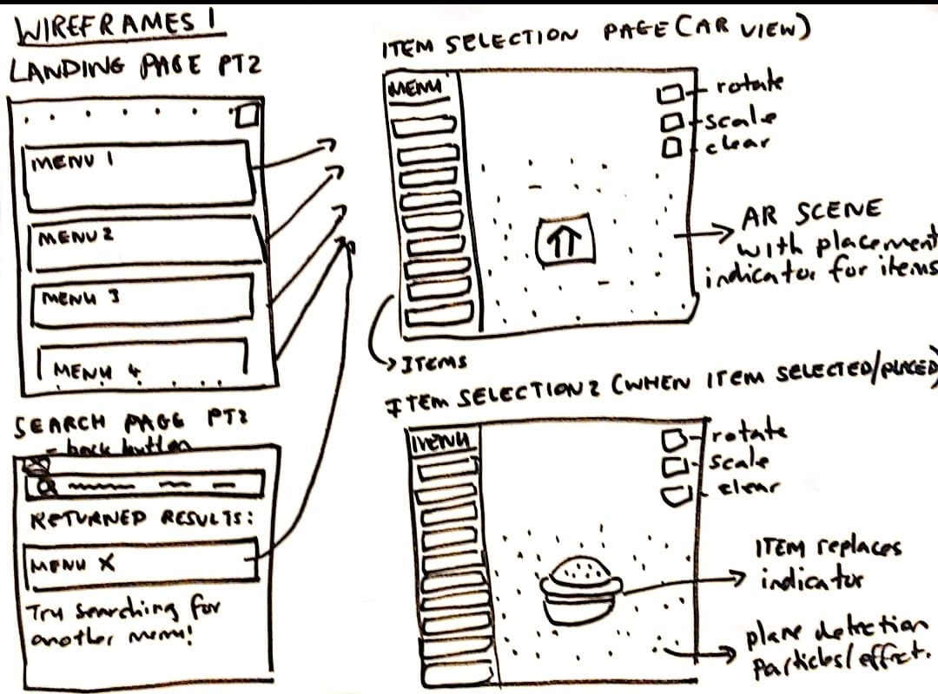

## Wireframe 2 - Page 1

The second of the three proposed wireframes designed for the Foodify application was also designed by me, considering a simpler UI layout from the first set of wireframes.

One of the first attempts to do this came from the home page, where users can either view all existing menus or search for a menu from the selection of menus available.

The selection of menus appear in category sub-headers, such as ‘Chinese’, ‘Indian’ and other such cuisines. This was the first time the idea of replacing the search bar functionality with the default idea of instead having menus displayed on the home page under menu sub-categories came from.

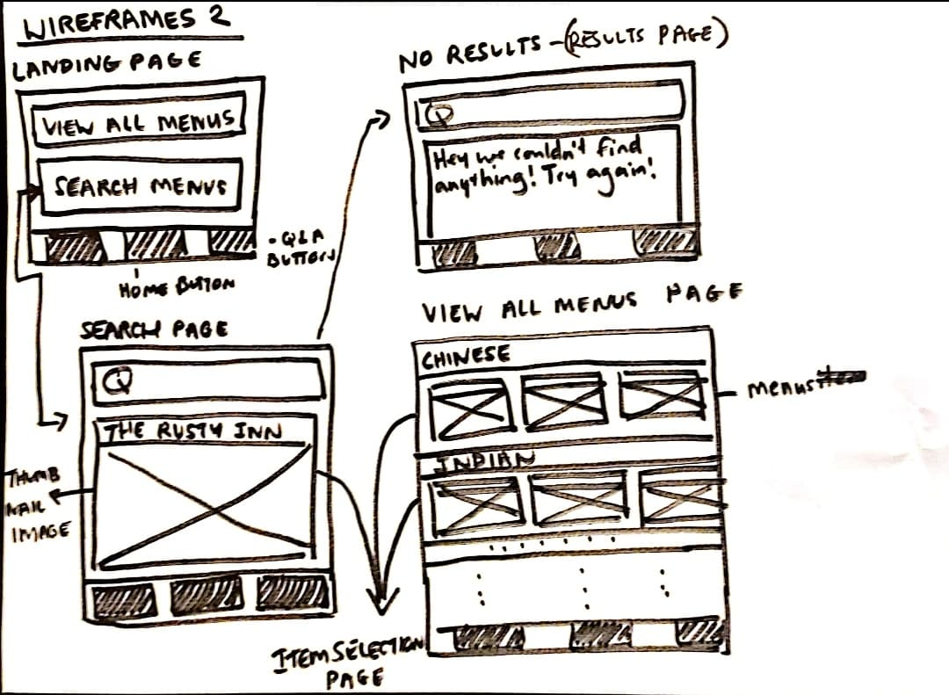

## Wireframe 2 – Page 2

The second page of the second set of wireframes is dedicated to the AR plane scene, similarly to the first set of wireframes.

Users can select an item from a scrollable item selection wheel which contains each AR item, and then place them on the AR plane. From there, users can move, rotate, scale or delete the currently placed AR item.

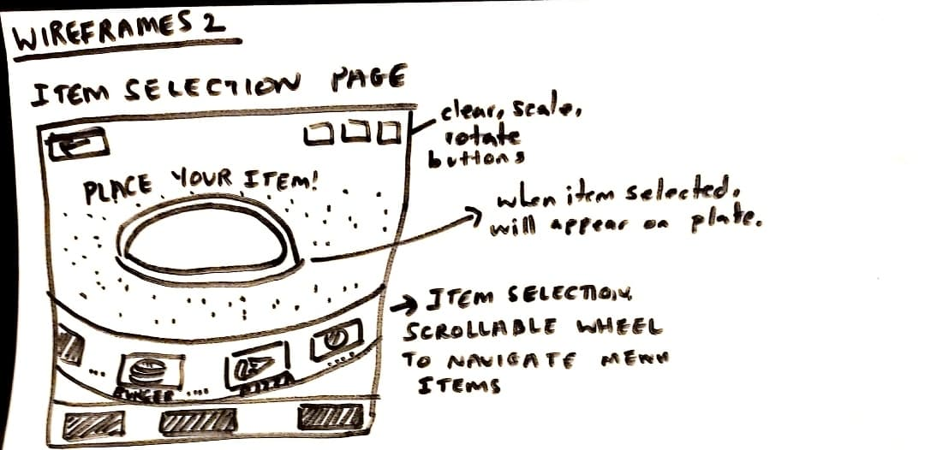

## Wireframe 3 – Using Existing Apps for UI design ideas

When considering designs for the design phase of the project, considerations had to be made for existing applications that revolve around the food and beverage market. Companies such as UberEats and Deliveroo boast millions of monthly customers and therefore hold UI that customers are familiar with. Instead of proposing a whole new UI format, the decision was made to use UI from the most popular fast-food restaurants as a basis for the application proposed.

Research into the most popular food-delivery applications in the UK led to Cliffex’s article on the “Top 5 Food Delivering Apps in the UK” <https://cliffex.com/blog/5-food-delivering-apps-in-the-uk/> in which the article discusses features and functionality each app offer.

Further research led to narrowing these five applications to three: UberEats, Deliveroo and JustEat.

Whilst all three have their own pros and cons, JustEat’s functionality was tailored more towards the ordering process of food rather than the UI and so focus was paid on UberEats and Deliveroo. Logan Merrick’s article comparing the two raised interesting points for both <https://medium.com/@LoganTjm/ubereats-vs-deliveroo-which-app-has-the-best-user-experience-8fc41a7f830a>, and whilst his ultimate decision favoured Deliveroo, the choice was made to base the third set of wireframes around UberEats user interface due to its suitability with the application developed by the author.

## Wireframes 3 – Page 1

The final set of wireframes were heavily influenced by the UI found within the fast food application, UberEats. A lot of UberEat’s existing layout fit the template of the Foodify app functionality, hence the decision to choose it as a base template for the application.

The application begins at a landing page where users are given a choice of menus to select from, all sub-divided by categoric types (Indian Cuisine, Chinese, e.t.c). Users can select from the search bar to search for menu items or the help page for an instructional guide on how to use the app. Users can select the home button to return to the home page from either the search page or the help page.

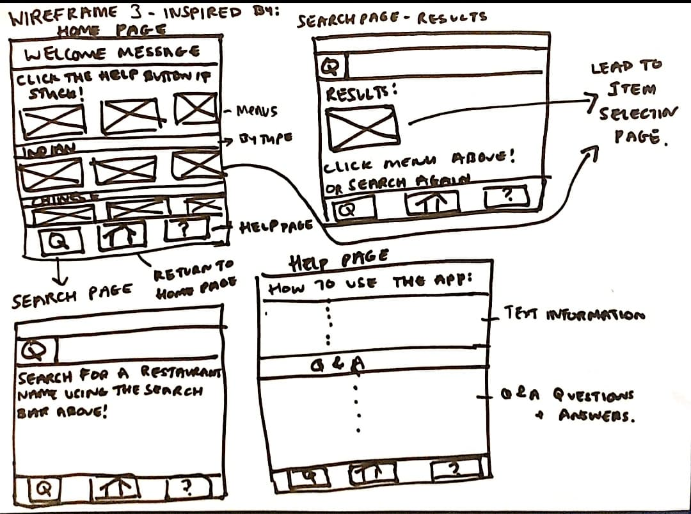

## Wireframe 3 – Page 2

This page is for the AR plane scene, where users can select items from a menu, filtered by category type (starters, mains, desserts, drinks, sides) to choose AR items from, which they can then place and view in augmented reality.

The clear, scale, rotate and move button are also included here as core functionality.

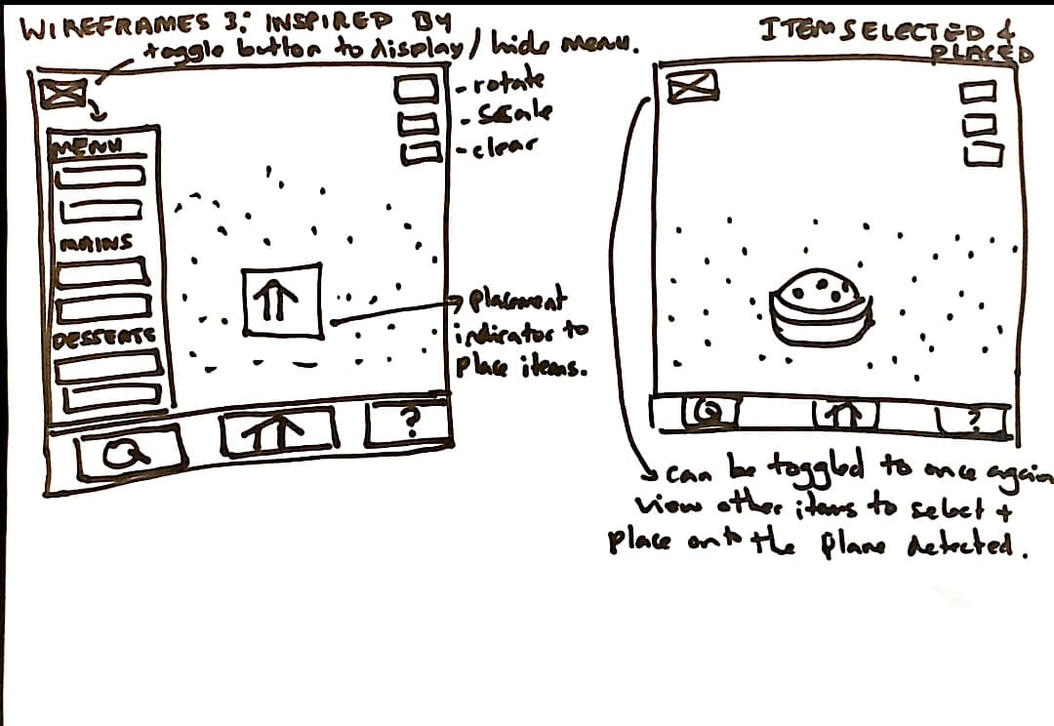

# Chosen wireframes

From the selected wireframes drawn above, the third set of wireframes have been chosen to be adapted during the development stages of the project.

When contrasting the three designed wireframes, the first two had some aspects of their UI that were useful. However, these wireframes were designed by creator of the project, so there may be some bias in how good the wireframes are. To add to this, the wireframes influenced by UberEats’ app UI will prove to be much more user-friendly to those who have never tried the Foodify app out before.

This is because UberEats is one of the largest mobile applications in the food and beverage industry, boasting a huge number of users per monthly basis. For those using the UberEats application, transitioning to another application that has a completely different UI may be difficult to grasp for some users and turn them away from the actual functionality that Foodify has to offer.

Furthermore, UberEats has most likely invested countless resources into the design and implementation of their UI so using their existing layout as a template for Foodify could draw user’s attention away from how the application looks, so they can focus on the functionality the application has to offer. The third set of wireframes also fit the functionality set out to create within the requirements specification document, therefore being the most viable option of the three wireframe designs proposed.

# Wireframes created in Adobe XD

This section of the document showcases the wireframe designs of each individual page within the application, how they interact with each other and how users would navigate through the application.

Whilst the layout serves as a template for the implementation stage of the project, certain functionality included may be replaced or removed based on their necessity or requirements.

# Individual Pages

These are the wireframe designs for each page.

# Home Page

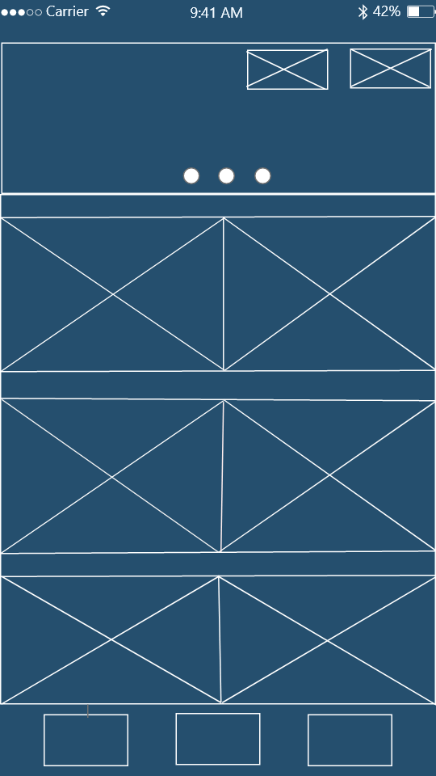

# Search Page

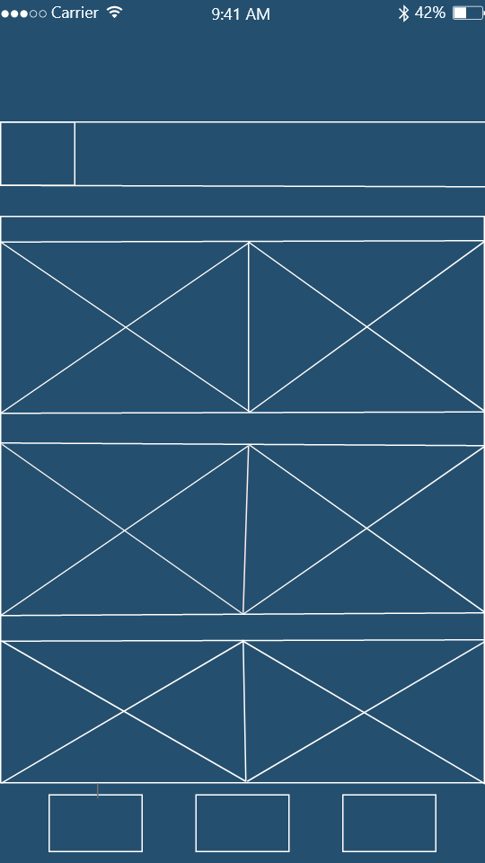

# Help Page

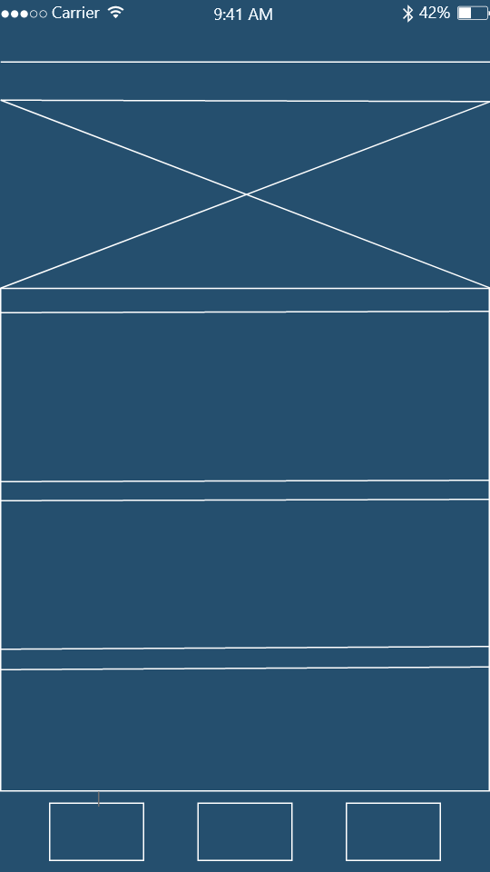

# Item Selection Page - 1

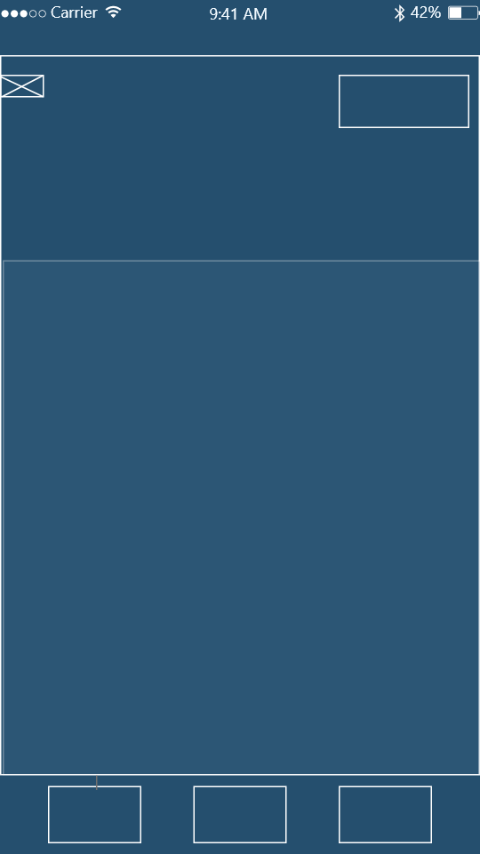

# Item Selection Page 2

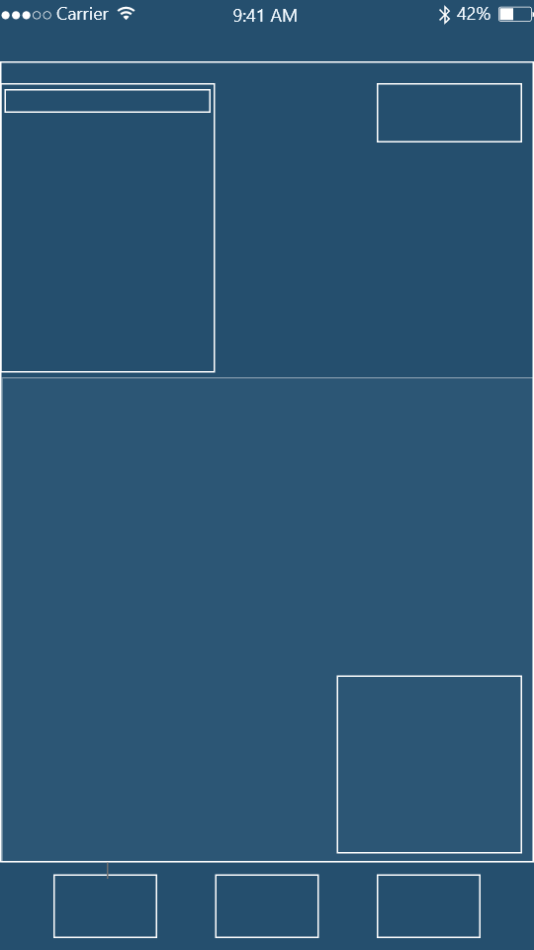

# Wireframe Interactivity Breakdown

Adobe XD also offers the functionality of mapping out interactions between designed wireframe pages. This is an excellent way of referencing buttons or pages that lead to other pages and help users understand the flow of each page.

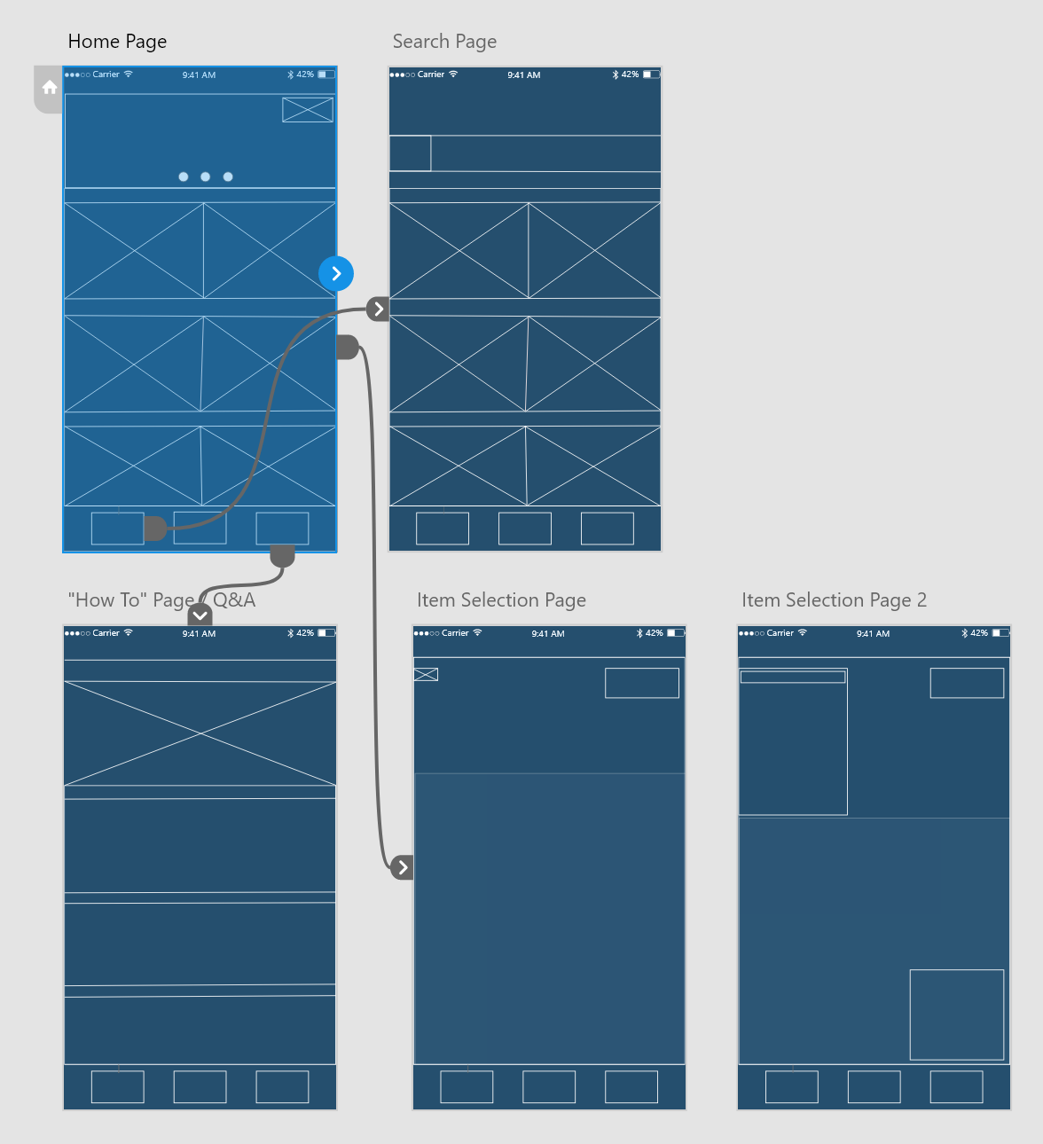

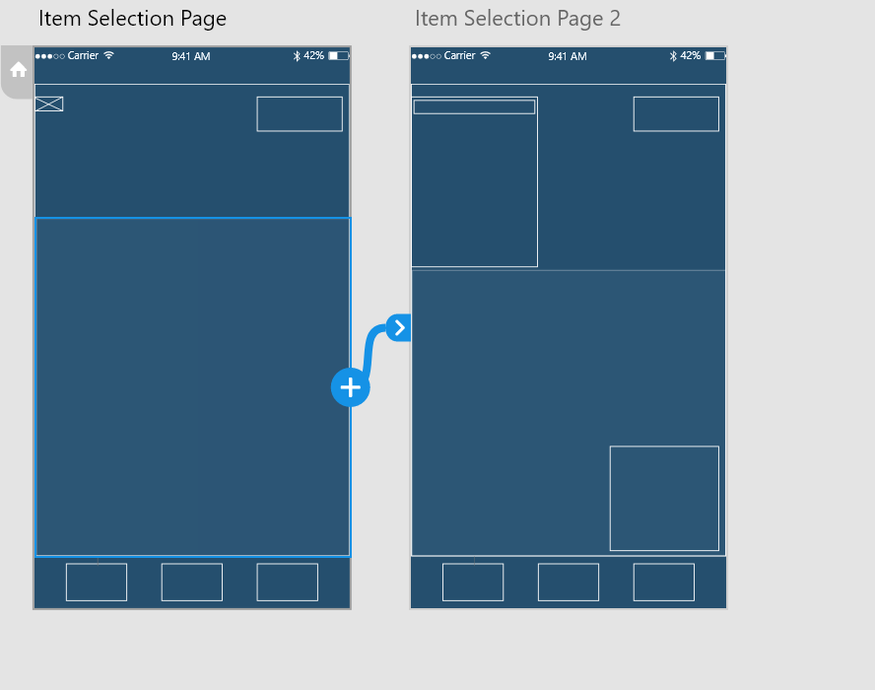

The above two images show a very brief overview of my wireframes and the interactions seen between them. As you can see from the first image, the ‘Home Page’ artboard connects to every single other page except ‘Item Selection Page 2’, which can only be accessed from the original ‘Item Selection Page’. This is shown in the second image attached above.

# **Home Page**

A button to access the price filter page.

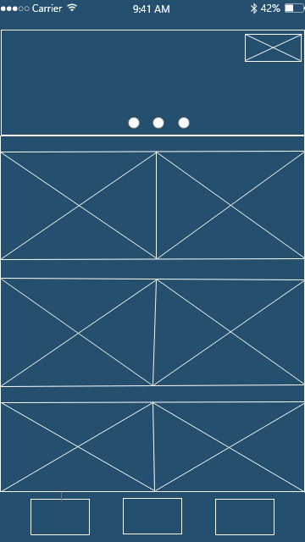

Welcome images for the app itself, can include menu products or menus.

These are the restaurants themselves. Attached will be the restaurants image and the restaurant name above their image. This should involve an infinite scroll option to see all possible products.

A ‘search’ button that leads the user to the search page. Users should be able to search for products or restaurants.

A button to access the help-page. This shows the user how to use the app and common questions users may have about the app.

This is the ‘Home Page’ button. When selected in any other page other than the home page, it should re-direct the user back to this page. If selected in the home page, nothing should happen.

# **Search Filtering**

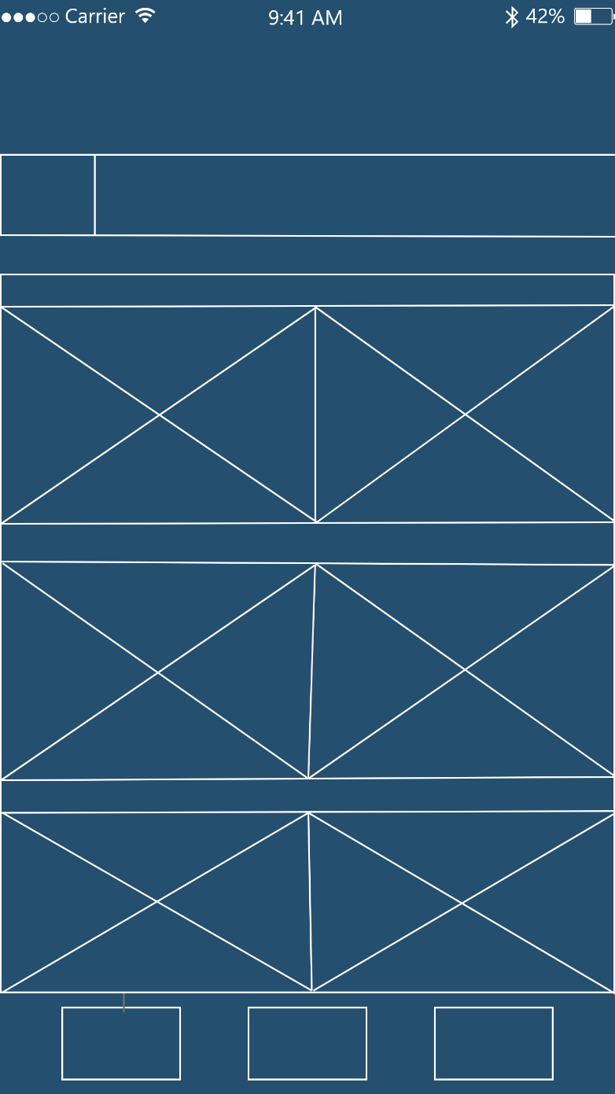This page aims at helping users manually search for specific products or menus from a list, if they can’t find them manually.

A list of restaurants as found from the home menu page.

A search bar to type in products or restaurants to look for. Relevant restaurants that match the search item or menu should appear.

The Home Menu button.

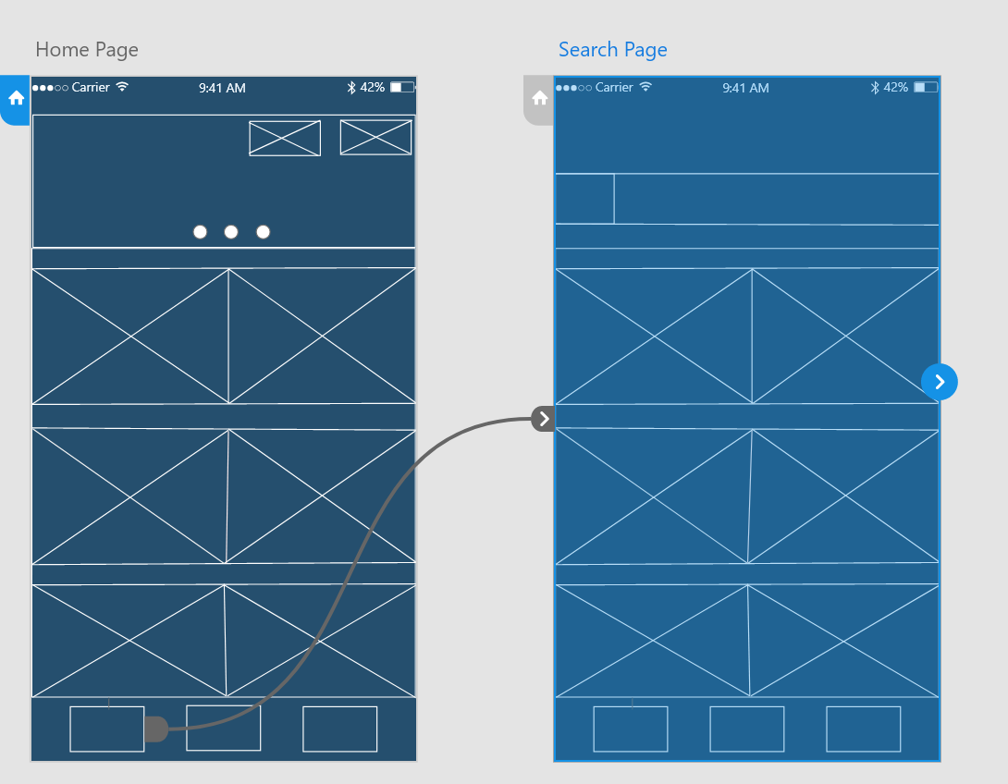

Interactions between the Home Page and the Search Filter page.

# **How-To Page**

This page aims at helping users find their way around the app. Including:

* How to use the app
* Where to select items from
* How to get to the right pages
* Common FAQ questions.

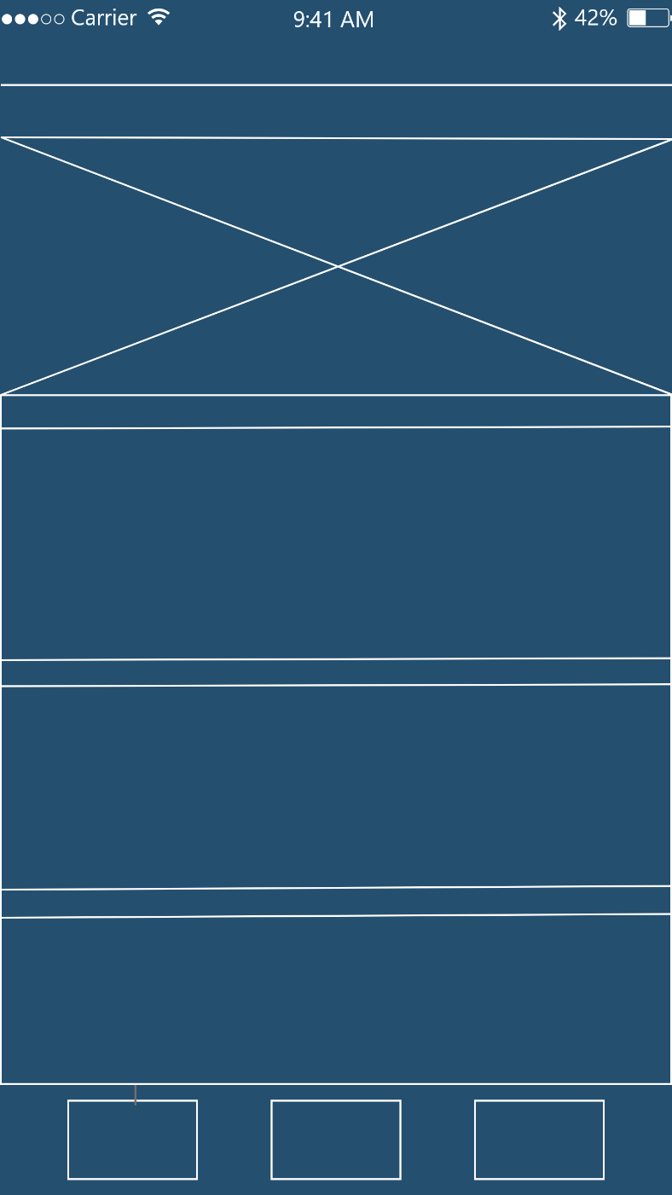

The FAQ section with relevant questions and answers regarding how to use the app.

An instructional image guide showcasing how to navigate through the app.

The Home Menu button

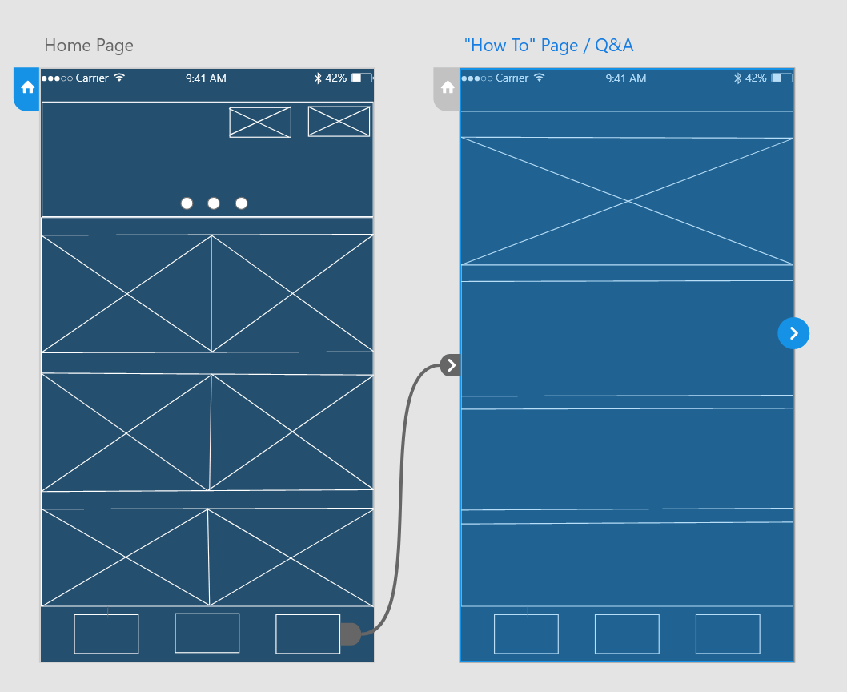

Interactions between the Home Page and the “How To” Page.

# **Item Selection page**

This page is where the majority of functionality arrives from my application.

Users should be able to select an item from a menu (that they will have previously selected), and then place the product on an AR plane and view it in a range of different angles.

Users should also be able to clear all instances of items placed on the AR plane or click the home menu button to go back to the original page.

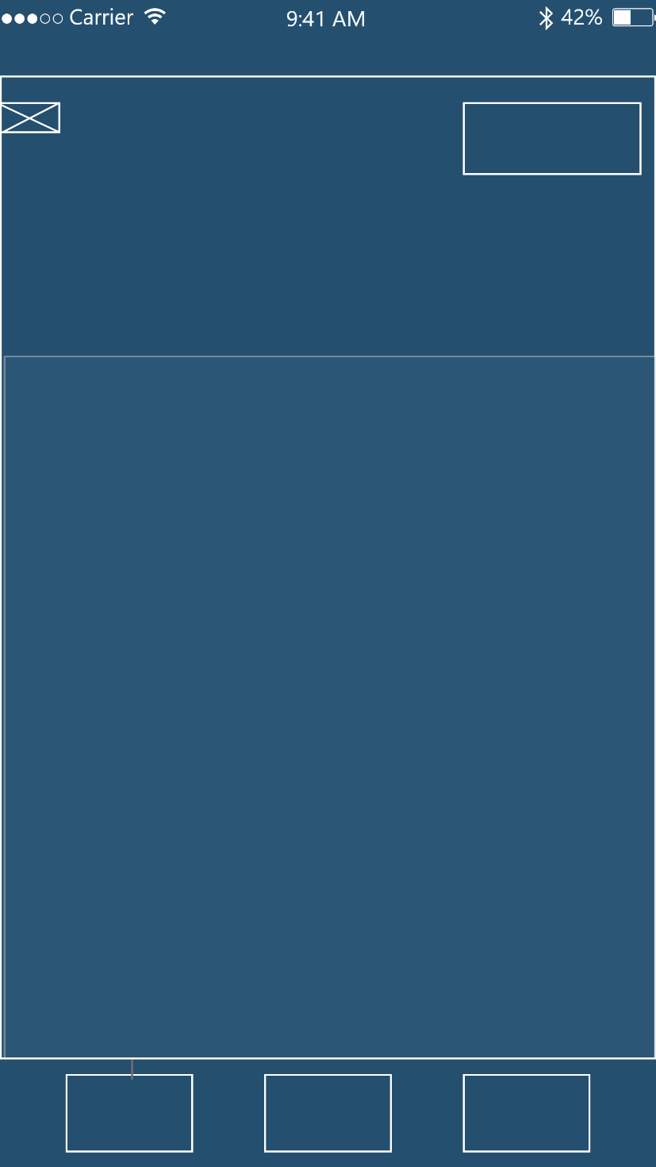

The AR plane where users can then place items from a real-world view of their camera.

A selectable button that once clicked, will show the relevant restaurant menu with products for the user to select and place onto the given AR plane.

A clear button to clear all instances of items on a plane.

The Home Menu button.

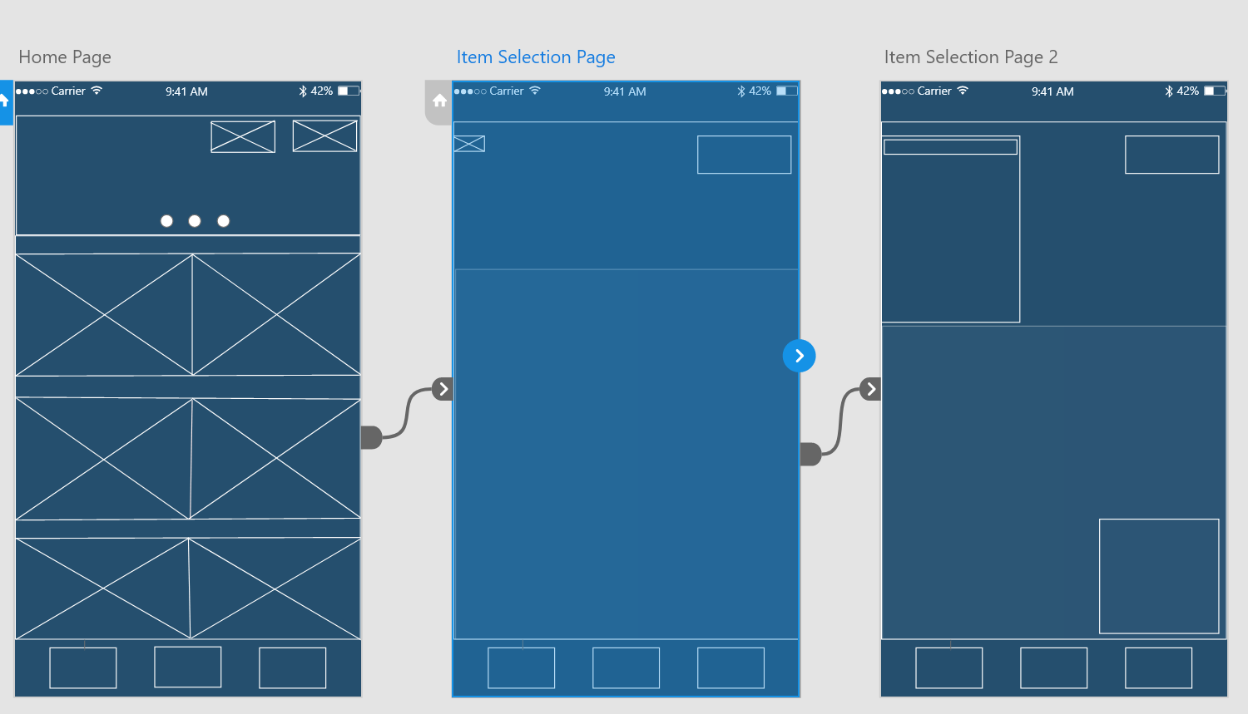

The interactions between the Home Page and the ‘Item Selection Page’. This also showcases the hierarchy between the relevant pages, as the Item Selection Page 2 arrives from selecting items from the original ‘Item Selection Page’.

# **Item Selection Page 2**

A continuation from Item Selection Page 1 (not as a new page, but existing to showcase the functionality of the application once certain buttons are pressed).

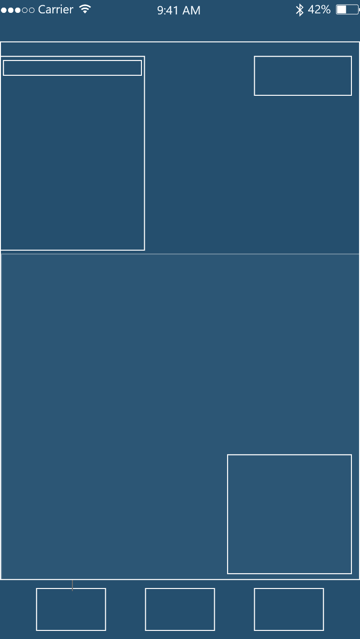

A brief description of the product – this could include what’s inside the product or just a general product overview.

The clear button.

From the first selection page button, once clicked, the menu itself will appear. Users can select a menu item and see an associative price attached to that item.

The Home Menu button.

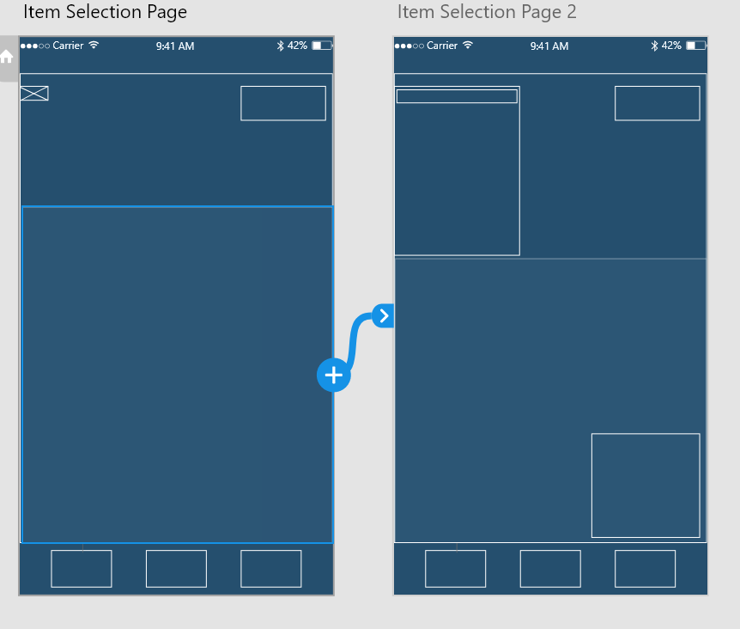

The interaction between the Item Selection Page and Item Selection Page 2.

Whilst Item Selection Page 1 and 2 are not different pages, the purpose of showcasing them as two different pages is for functionality and implementation references – these will help me understand how the features of the original page should be implemented (such as placing AR items, scaling items, e.t.c).